# Project Proposal On

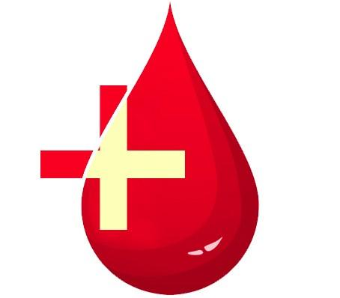

Module: STW300CEM Android Applications Development

Softwarica College of IT & E-Commerce

Mahakavi Marg, Kathmandu, Nepal

Submitted By: Submitted To:

Tej Singh Chaudhary Kiran Rana

College id: 140149 Module Leader

Table of Contents

Project Proposal On 1

Blood Bank 1

Introduction 3

1. 3

a. Project Introduction 3

b. Justification of the project 3

i. Background of the project 3

ii. Problem Statement 3

c. Description of the project 3

i. Features of the project 3

2. Aims and objective of the project 4

Aims 4

Objective 4

3. Development Methodology 5

Waterfall Model 5

Advantages 6

Disadvantages 6

4. Configuration Management 7

5. Prototype 8

6. Conclusion 12

7. References 13

# Introduction

# 1.

# a. Project Introduction

In a world of full of technology, still the records of blood donors are kept in papers and registers. It is difficult as they may tear down as time passes, papers may lose, checking records were difficult. So, to overcome this issue, android application “Blood Bank” is developed. This is will people to upload every donor donated bloods, see details and contact them when needed.

# b. Justification of the project

The outcome of this project is it will help the people to save the donors details, managed and all listed for future use.

# Background of the project

The main purpose of develop this application is to provide managed list of all donors, which happens place to place or anywhere, and they need to be kept properly and securely so that it can be helpful for others who are need of bloods. All the data are secured and properly kept because they are uploaded to the server.

# Problem Statement

The problem with this application is that this application is only available to android smart phones and with android version 5.0 and above. Another people might face is they cannot save the data offline as they have to login first. So, if the users do not have internet connection, they cannot access to the application.

# c. Description of the project

# Features of the project

* Login for both admin and users
* Only admin can create other users
* Only users can create and enter donor details.
* Admin can delete user details or account
* Admin can update user details
* User can delete donor’s details
* User can update donor’s details.
* Global search, where users can search blood types.
* Show address of user keeping the record when the user searches for the blood.
* Give contact number and address of hospitals and Red Cross Society, who provide blood service.

# 2. Aims and objective of the project

# Aims

The aims of this project are as follows:

* To save data and details of donors securely

# Objective

The objectives of this project are as follows:

* To save all the donor’s details properly so that no one gets left out.
* To give service to people who are in need of blood who can’t find them.
* Easy to access and use and can be accessed with android smartphones.

# 3. Development Methodology

# Waterfall Model

As my requirements are fixed and easy to understand and use, Waterfall Model will be used to develop this application. Development of waterfall model is done according to the steps given, and are followed accordingly to the end of the development of the application. (TRY QA.com, 2019)

Figure 1waterfall model

**Implementation**

**Requirement Analysis**

**Deployment**

**Testing**

**Implementation**

**System Design**

# Advantages

* Project is short and all the requirements are fixed and given.
* It doesn’t take much time to develop
* When one phase is completed then only next phase will be taking place.

# Disadvantages

* As this project is short and have fixed requirements, this model is not suitable for large projects.
* Since only after completing one phase, next phase will be going on, bugs and fixes should be done in development phase.
* Takes too much time for testing and when there are bugs at the end of the project, it will be too difficult to fix that.

# 4. Configuration Management

The process of maintaining the computer software and computer system in a known state. This is called configuration management.

<https://github.com/tejbijay/Blood-Bank>

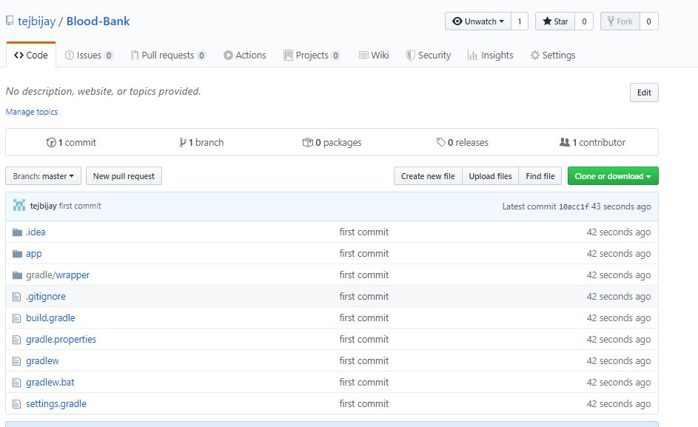

Figure 2 GitHub link

# 5. Prototype

A prototype is a rudimentary working sample, model, mock-up or just a simulation of the actual product based on which the other forms (final product, and variations) are develop. (feedough.com,2019)

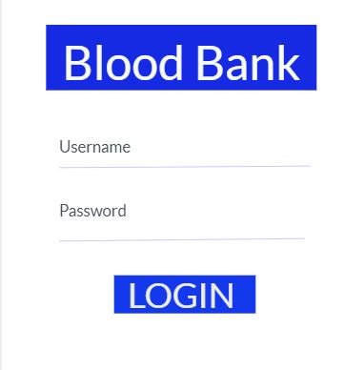

Figure 3 login form

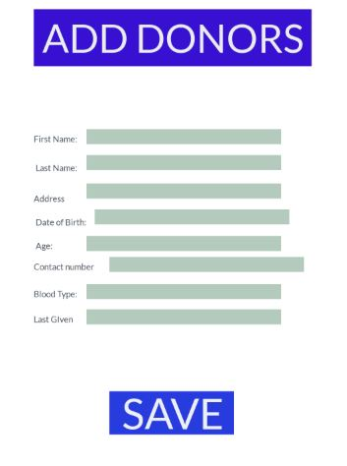

Figure 4 Add Donors

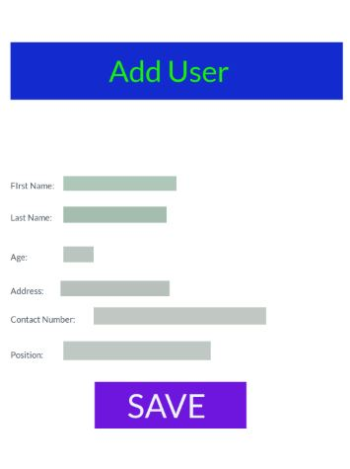

Figure 5 Add User

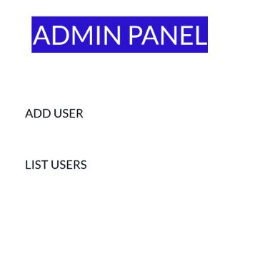

Figure 6 Admin Panel

df

# 6. Conclusion

Hence, this is the proposal for the application that will be going to be developed. With this proposal, the methodology which will be followed during the development of this application is also given along with the prototype, which shows how the application is going to be built.

# 7. References

. What Is A Prototype? - Examples, Types, & Qualities | Feedough. [ONLINE] Available at: https://www.feedough.com/what-is-a-prototype/. [Accessed 29 November 2019].

*What is Waterfall model- Examples, advantages, disadvantages & when to use it?*. [online] Tryqa.com. Available at: http://tryqa.com/what-is-waterfall-model-advantages-disadvantages-and-when-to-use-it/ [Accessed 29 November. 2019].